Assignment 12

Q1. WAJP to read double and float from user.

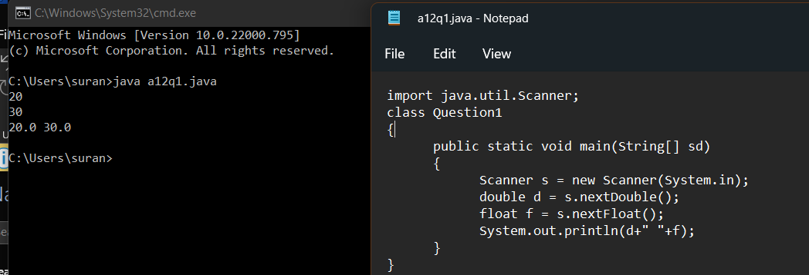

Q2. WAJP to read char and Boolean from user.

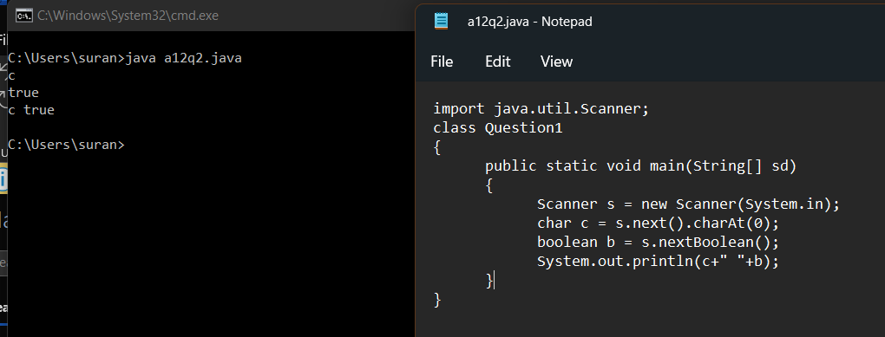

Q3. WAJP to read a sentence from user.

